Limit Switch
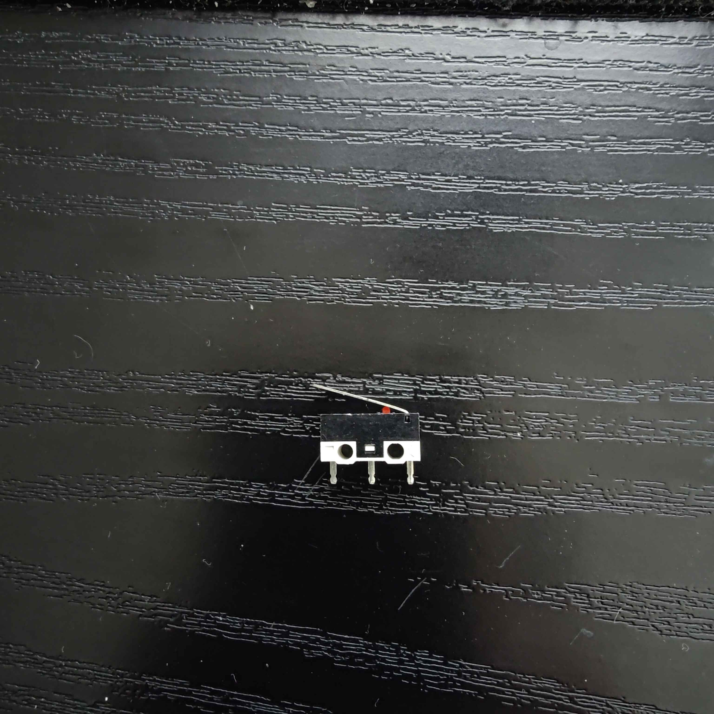
12.85 x 5.78mm
Motor Driver:
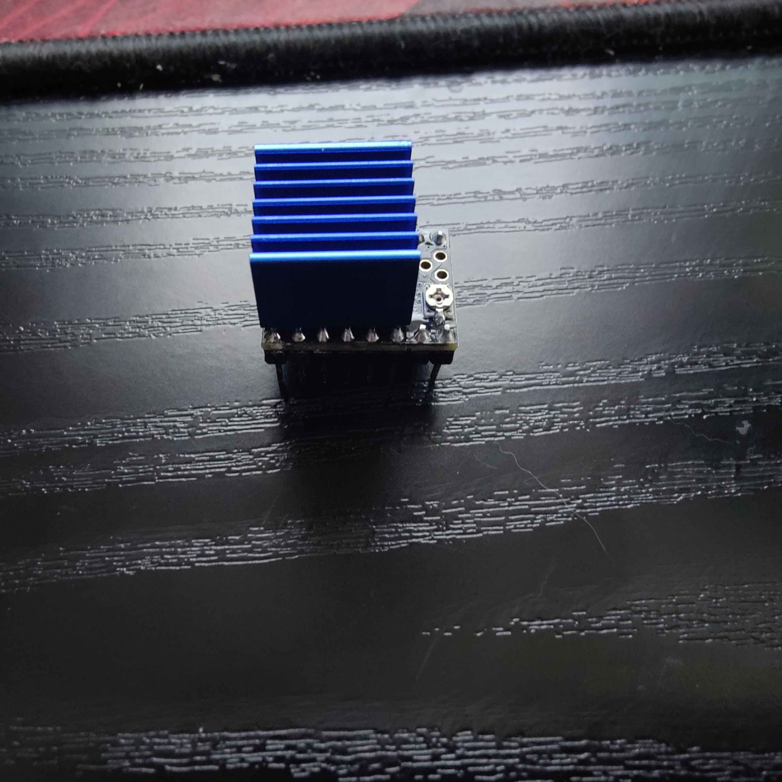

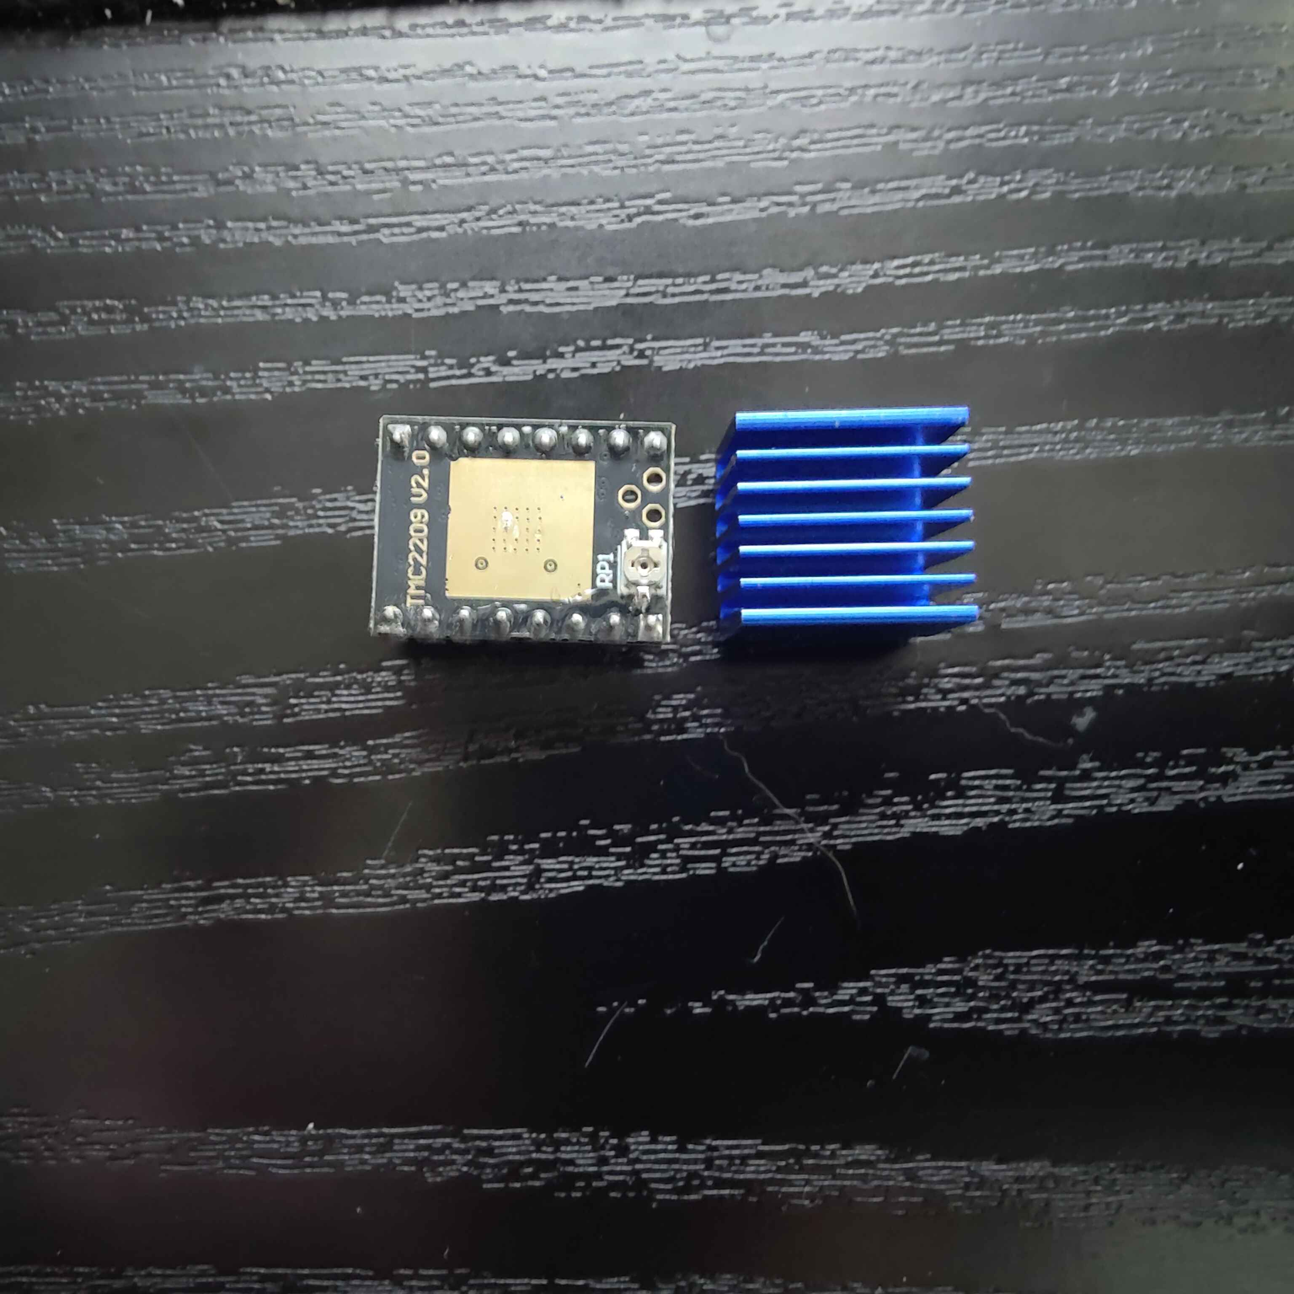
20.48 x 15mm
Laser:
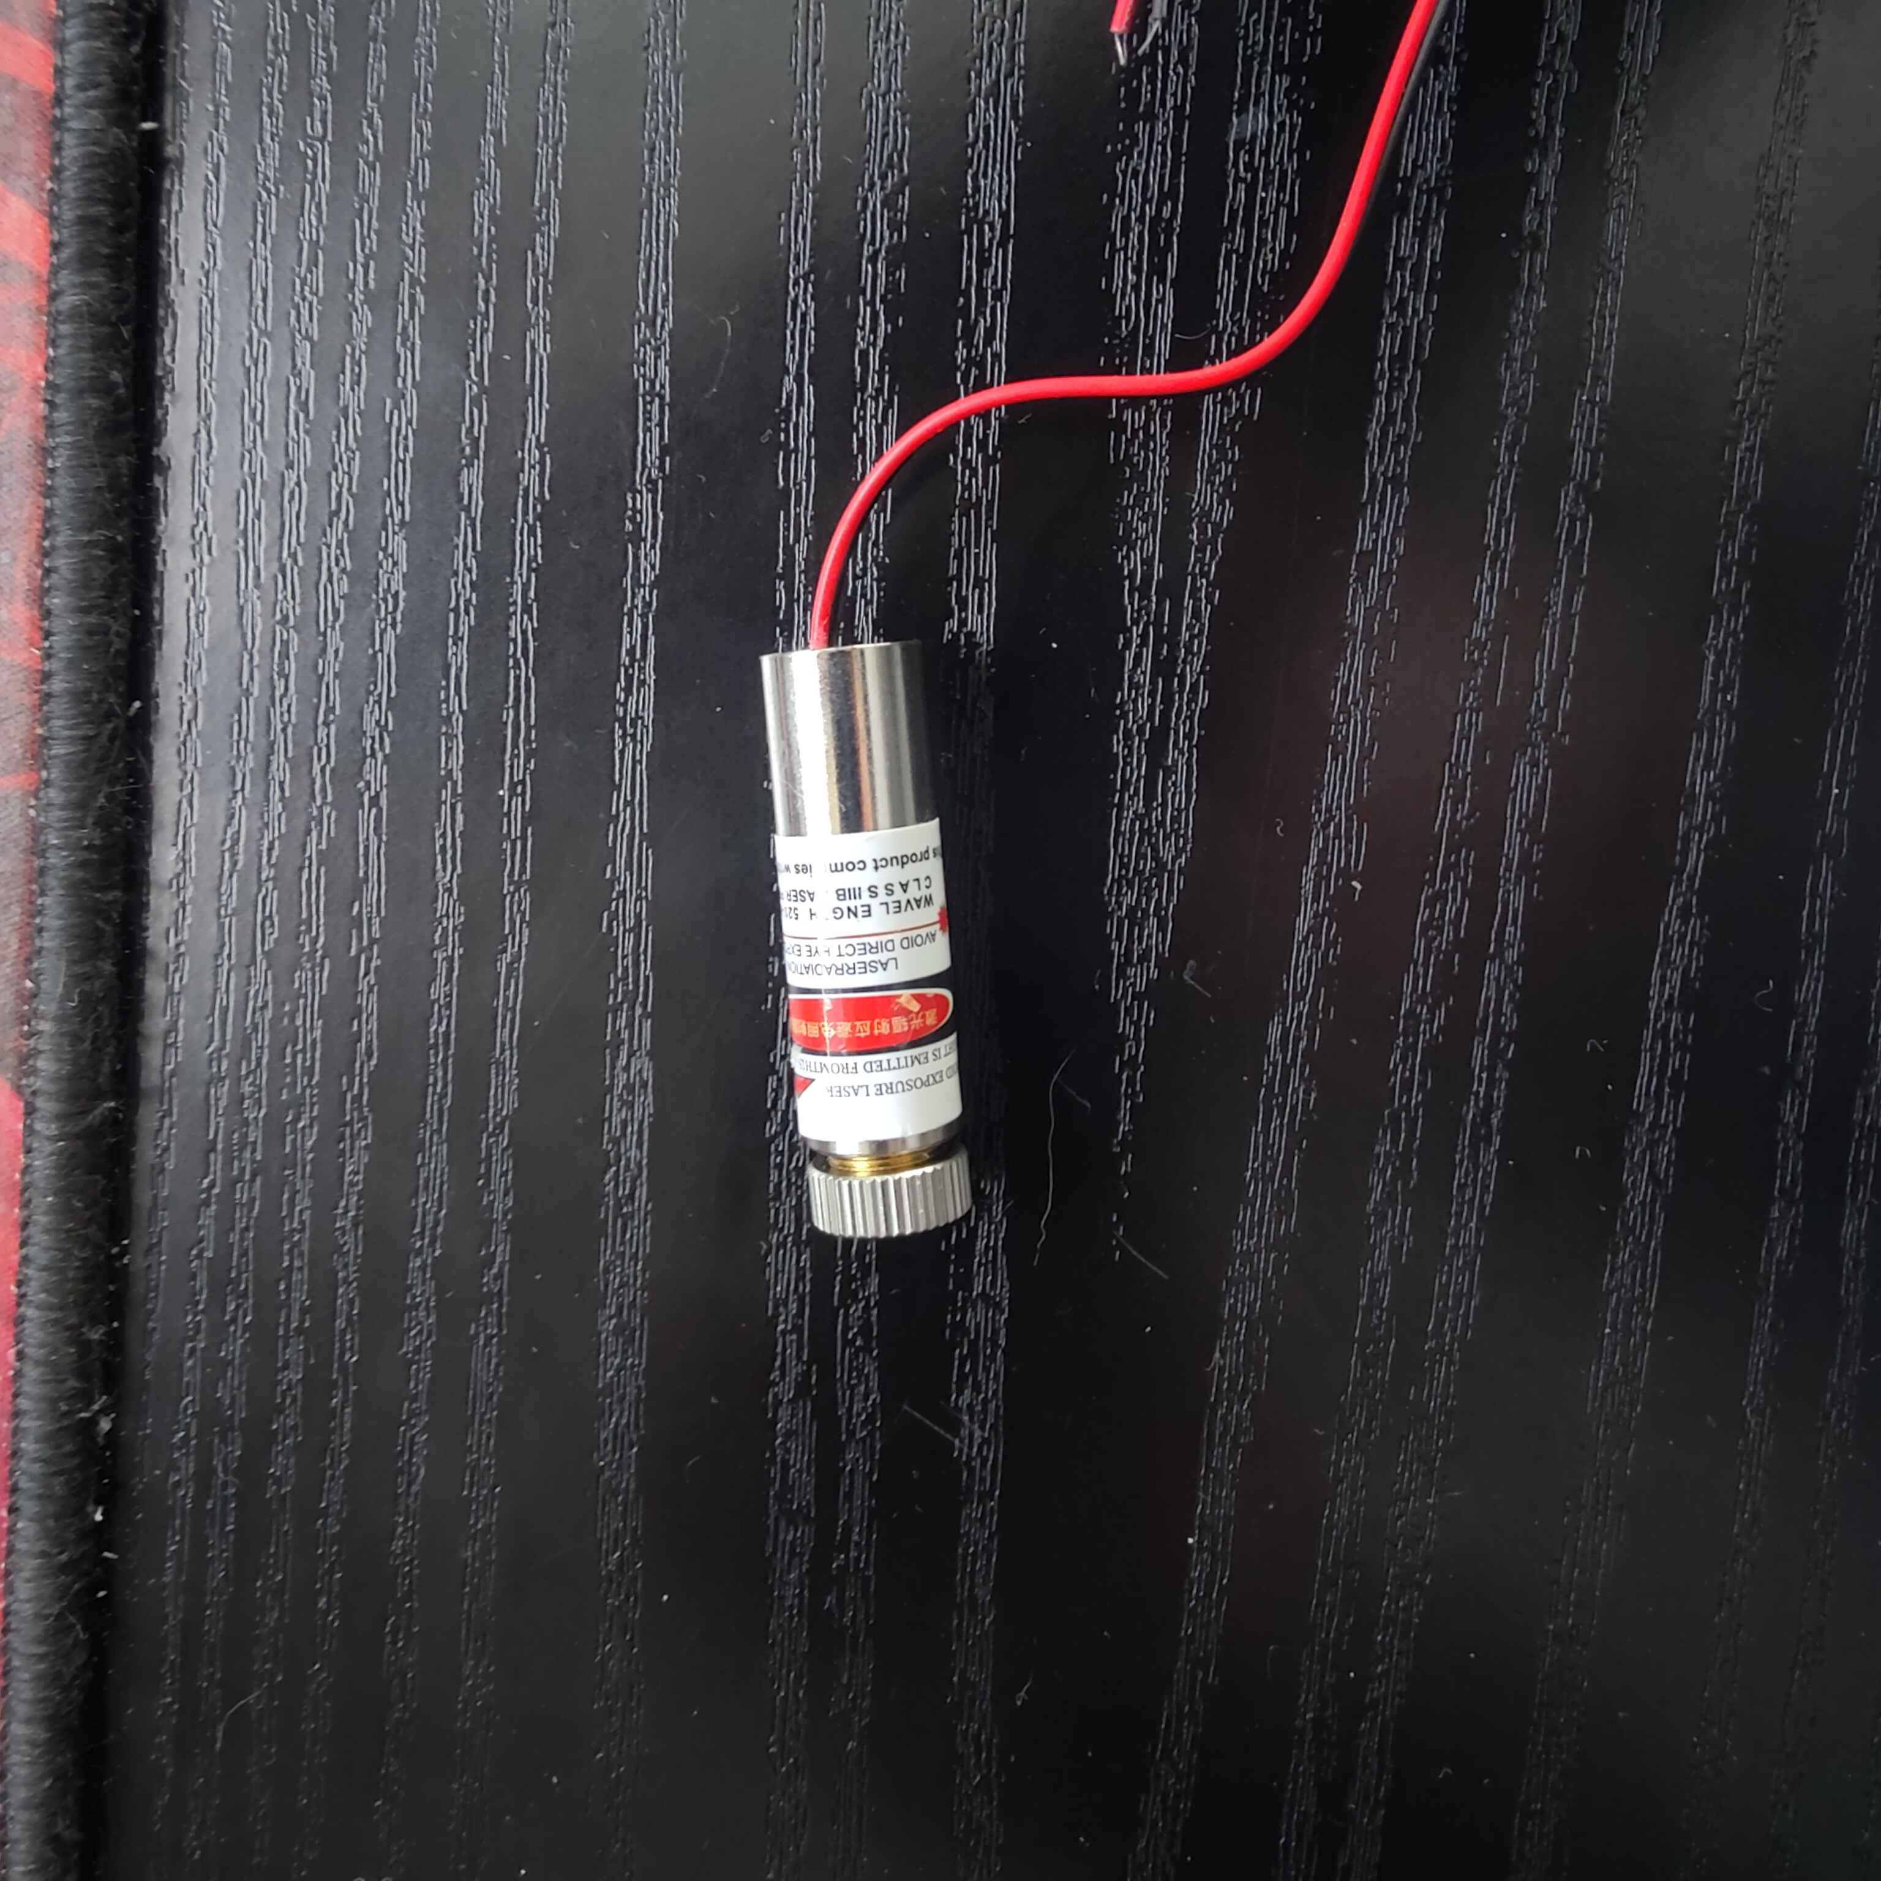
d = 12mm
h = 42.59mm

Pressure Gauge:
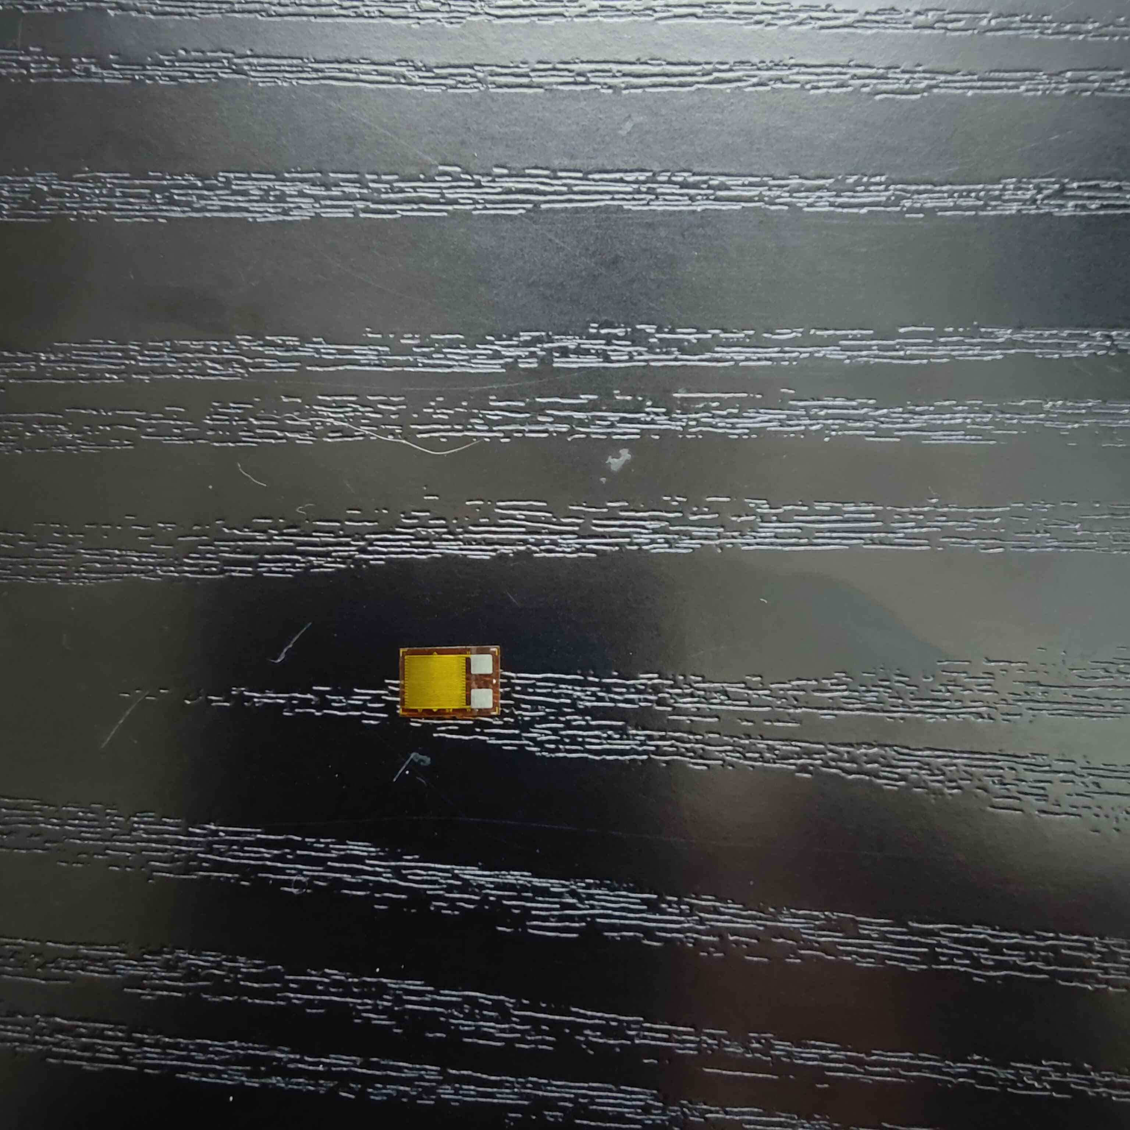
7.6 x 5.2mm
ToF Laser:
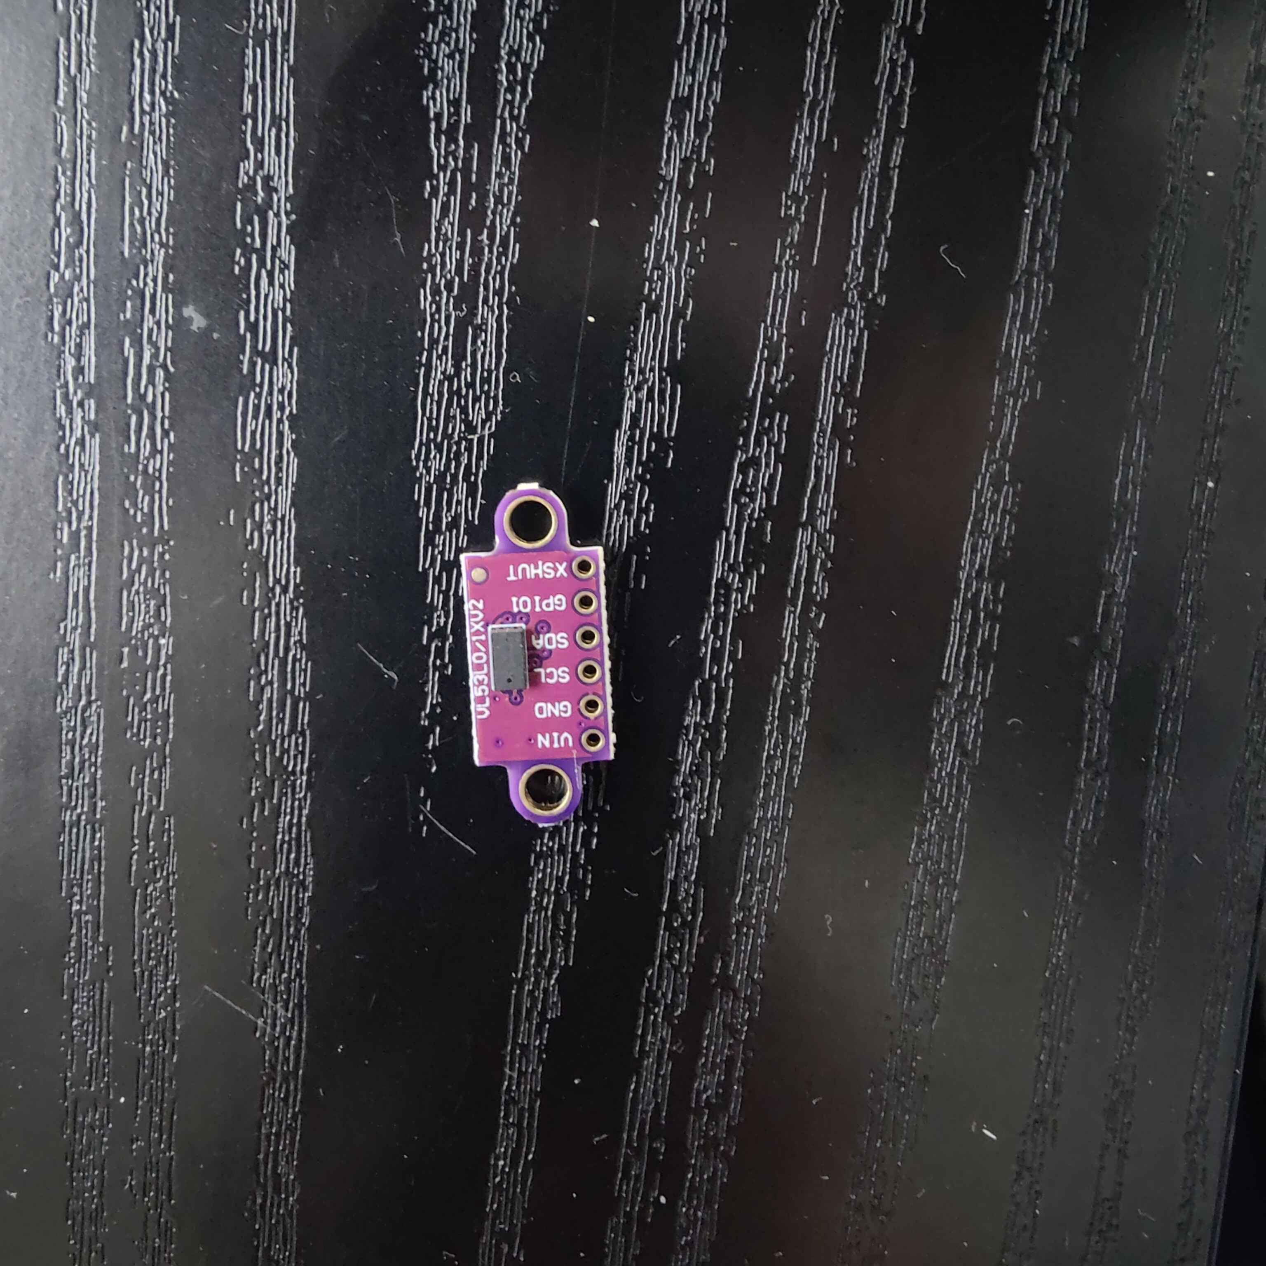
Dimensions without mounting holes:
15.64 x 12.29mm
Dimensions with mounting holes:
25.28 x12.29mm

PCB board:
Largest board:

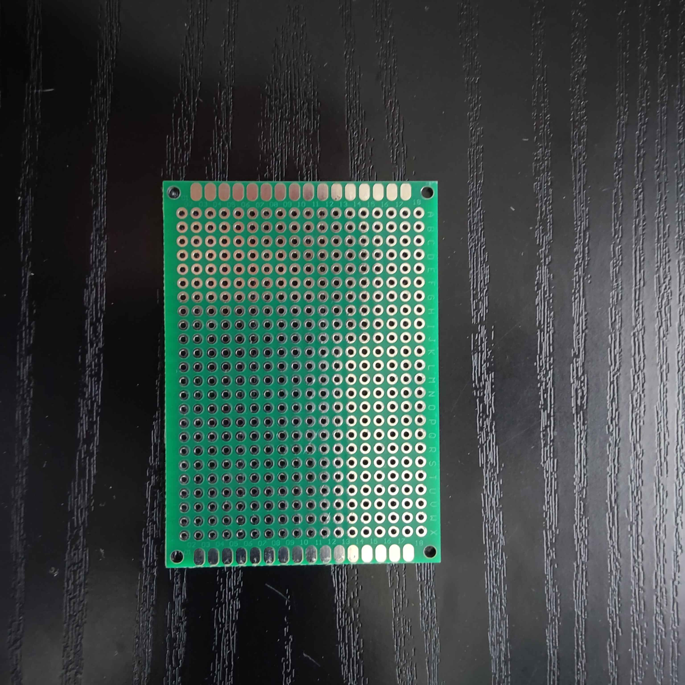
70.18 x 50.20mm
Medium board:

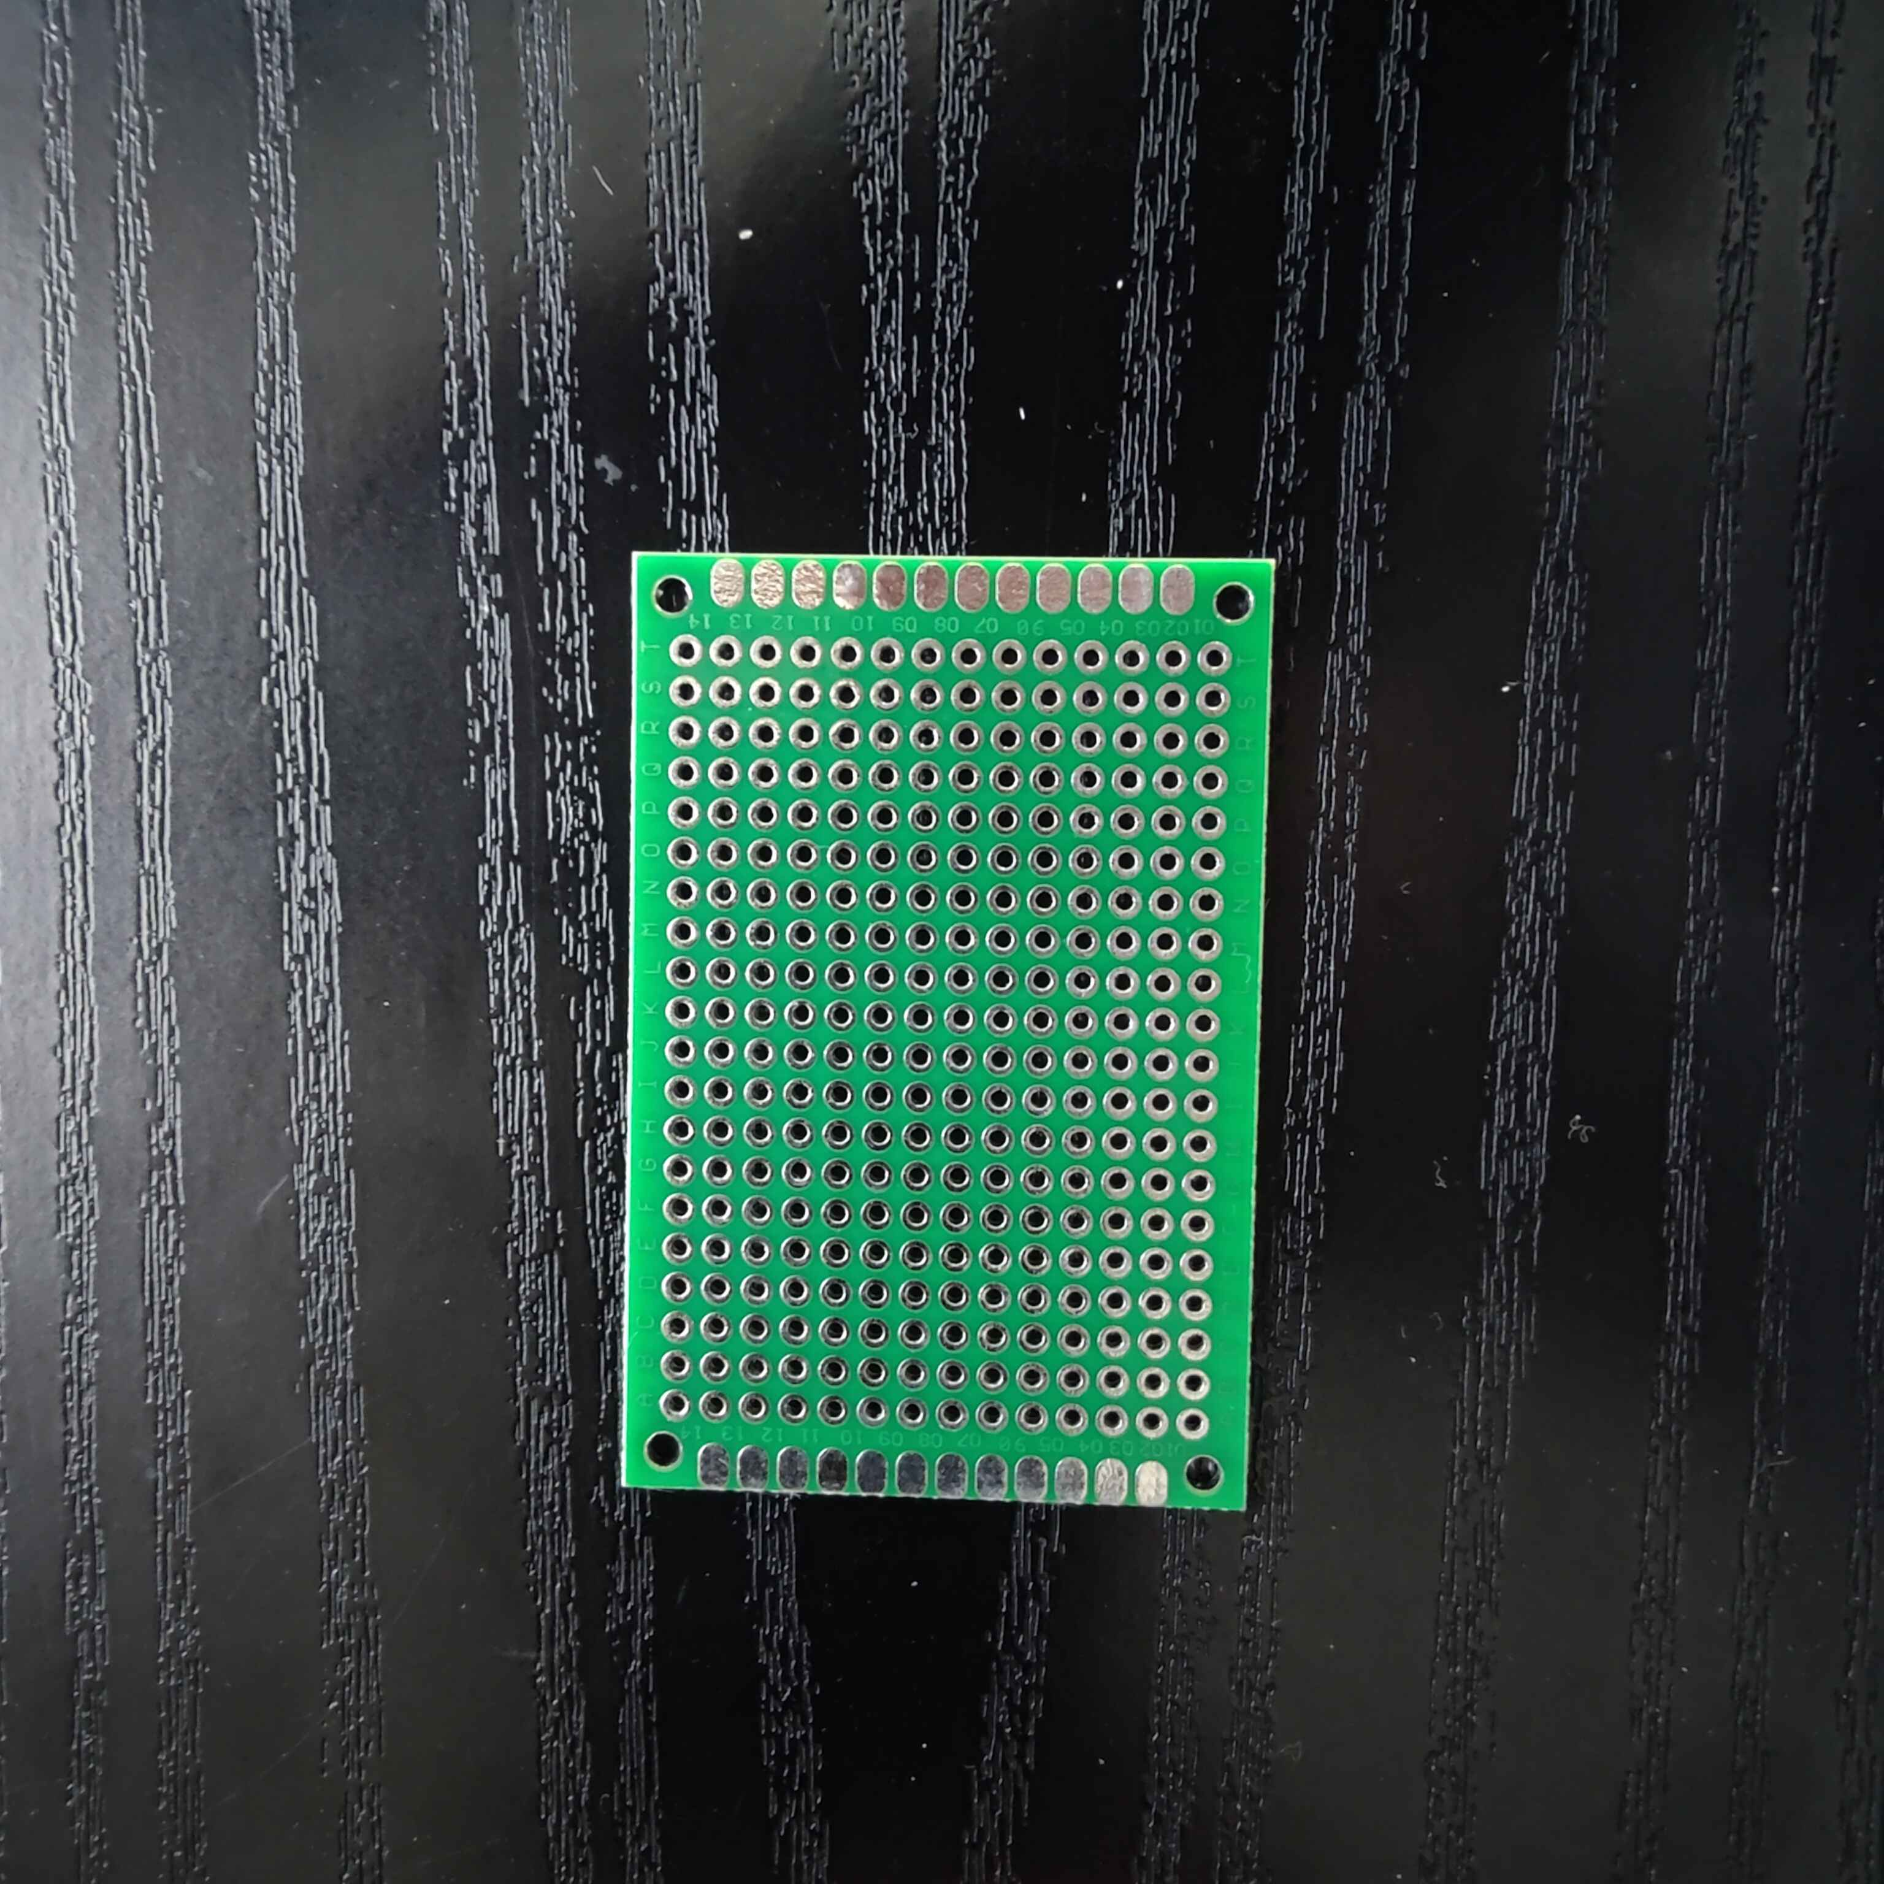
60 x 40.10mm

Battery Holder:
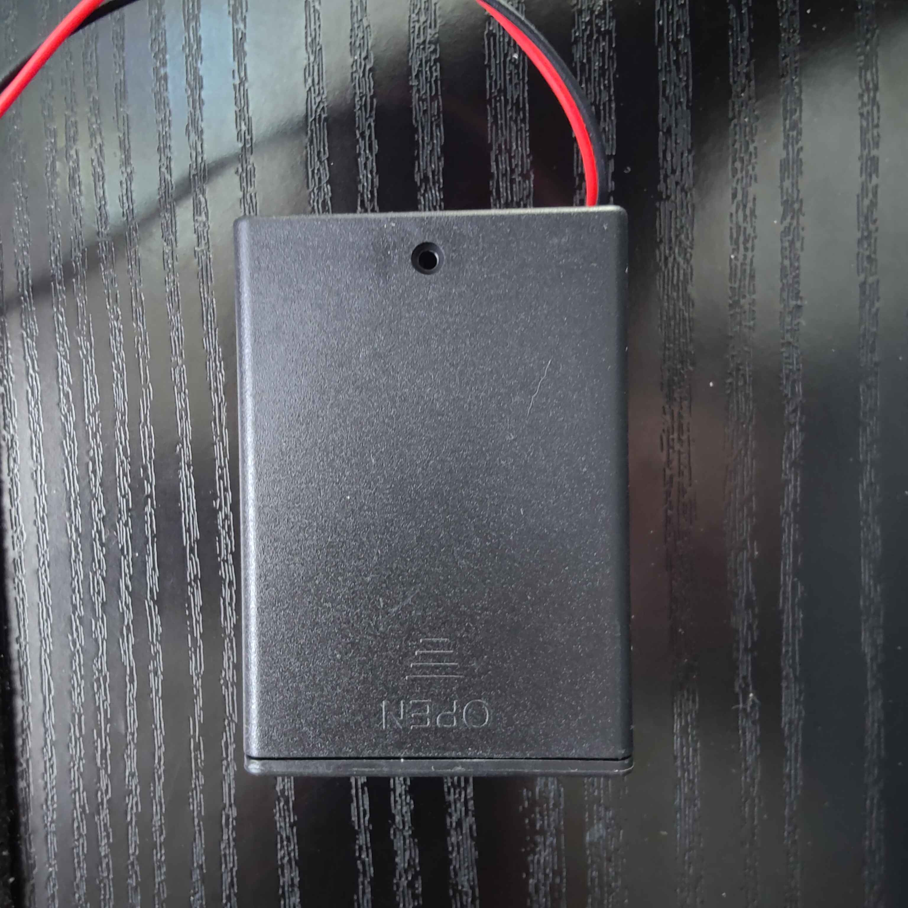
69 x 48.85mm

